T.Praneetha
192412588
ECA3102
Nano Electronics

EXP DEMONSTRATION OF QUANTUM TUNNELING
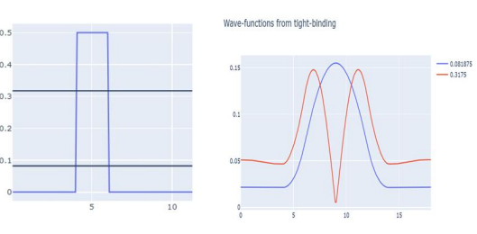
he objective was to demonstrate the phenomenon of quantum tunneling using the NanoHUB online simulation tool. The simulation was performed by creating a potential barrier and observing the behavior of electrons when they encounter it. The barrier parameters, such as height and width, were varied while keeping the other simulation settings constant. The purpose of this experiment was to understand how electrons can pass through a potential barrier even when they do not possess enough classical energy. The simulation shows that the tunneling probability depends on the barrier height and width—a thinner or lower barrier results in a higher tunneling probability, whereas a thicker or higher barrier reduces it. By analyzing the transmission probability graph, the experiment demonstrates the principles of quantum tunneling and its importance in nanoscale electronic devices.
Case study 1 : Analysis the transmission co-efficient Vs Energy characteristics on refined grid
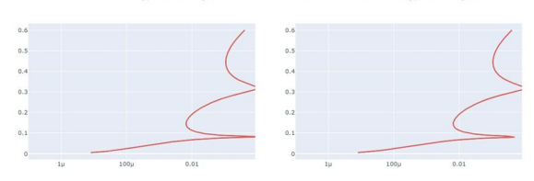
he objective was to analyze the Transmission Coefficient versus Energy characteristics using the NanoHUB online simulation tool. The simulation was carried out on a refined grid, which provides higher numerical accuracy while keeping the other simulation parameters constant. The purpose of this study was to observe how the transmission probability of electrons changes with energy during quantum tunneling. As the electron energy approaches or exceeds the potential barrier, the transmission coefficient increases, indicating a greater probability of tunneling through the barrier. By analyzing the transmission coefficient graph, the simulation demonstrates the relationship between electron energy and tunneling probability, highlighting the importance of quantum tunneling in nanoscale electronic devic
Case Study 2: Analyze the Reflection Coefficient vs Energy Characteristics on Homogeneous Grid
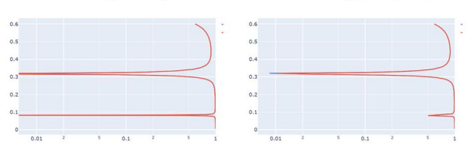

In Case Study 2, the objective was to analyze the Reflection Coefficient versus Energy characteristics using the NanoHUB online simulation tool. The simulation was performed on a homogeneous grid while keeping all other simulation parameters constant. The purpose of this study was to investigate how the reflection probability of electrons varies with energy when they encounter a potential barrier. At lower electron energies, the reflection coefficient is high because most electrons are reflected by the barrier. As the electron energy increases, the reflection coefficient decreases due to an increase in the tunneling and transmission probability. By analyzing the reflection coefficient graph, the simulation demonstrates the dependence of electron reflection on energy and explains the behavior of electrons in quantum tunneling systems.
Conclusion
The simulations successfully demonstrated the Transmission Coefficient vs Energy and Reflection Coefficient vs Energy characteristics. The results show that higher electron energy increases transmission and decreases reflection, confirming the principles of quantum tunneling and its importance in nanoscale semiconductor and electronic devices

